Explanation of Window Functions in MySQL
Window functions in MySQL are used to perform calculations across a set of table rows related to the current row. Unlike aggregate functions (e.g., SUM, AVG) that return a single result for a group of rows, window functions allow you to retain the original rows and include calculated results as additional columns. This is particularly useful for ranking, running totals, moving averages, and other complex calculations.
Common Window Functions:
- ROW_NUMBER() - Assigns a unique number to each row within a partition.
- RANK() - Assigns a rank to each row within a partition, with the same rank given to rows with equal values.
- DENSE_RANK() - Similar to RANK(), but without gaps in ranking.
- NTILE(n) - Divides rows into n groups, assigning a group number to each row.
- LAG() / LEAD() - Allows access to a row at a specified physical offset before/after the current row.
- SUM(), AVG(), COUNT() (when used as window functions) - Perform cumulative calculations over the window.


Example Dataset, Table Creation, and Data Insertion
Sample Data: Employee Sales Data
Let's create a table employee_sales that captures sales information, and then insert some sample data:
CREATE TABLE employee_sales (
SaleID INT PRIMARY KEY,
EmployeeID INT,
EmployeeName VARCHAR(50),
Region VARCHAR(20),
SaleAmount DECIMAL(10, 2),
SaleDate DATE
);

INSERT INTO employee_sales (SaleID, EmployeeID, EmployeeName, Region, SaleAmount, SaleDate) VALUES
(1, 101, 'Alice', 'North', 500, '2024-10-01'),
(2, 102, 'Bob', 'East', 600, '2024-10-02'),
(3, 103, 'Charlie', 'North', 800, '2024-10-03'),
(4, 104, 'David', 'West', 700, '2024-10-04'),
(5, 101, 'Alice', 'North', 900, '2024-10-05'),
(6, 102, 'Bob', 'East', 400, '2024-10-06'),
(7, 103, 'Charlie', 'North', 750, '2024-10-07'),
(8, 104, 'David', 'West', 500, '2024-10-08'),
(9, 101, 'Alice', 'North', 600, '2024-10-09'),
(10, 102, 'Bob', 'East', 700, '2024-10-10'),
(11, 103, 'Charlie', 'North', 650, '2024-10-11'),
(12, 104, 'David', 'West', 850, '2024-10-12'),
(13, 101, 'Alice', 'North', 400, '2024-10-13'),
(14, 102, 'Bob', 'East', 800, '2024-10-14'),
(15, 103, 'Charlie', 'North', 900, '2024-10-15'),
(16, 104, 'David', 'West', 650, '2024-10-16'),
(17, 101, 'Alice', 'North', 700, '2024-10-17'),
(18, 102, 'Bob', 'East', 750, '2024-10-18'),
(19, 103, 'Charlie', 'North', 850, '2024-10-19'),
(20, 104, 'David', 'West', 950, '2024-10-20');
Practice Questions and Solutions:
- Find the cumulative sales total for each employee.
SELECT EmployeeID, EmployeeName, SaleDate, SaleAmount,
SUM(SaleAmount) OVER (PARTITION BY EmployeeID ORDER BY SaleDate) AS CumulativeSales
FROM employee_sales;
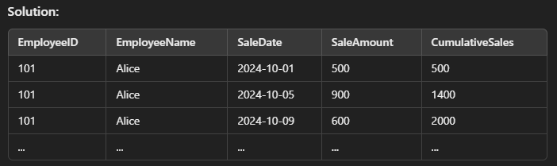
- Rank the employees' sales within each region by SaleAmount.
SELECT EmployeeID, EmployeeName, Region, SaleAmount,
RANK() OVER (PARTITION BY Region ORDER BY SaleAmount DESC) AS SalesRank
FROM employee_sales;
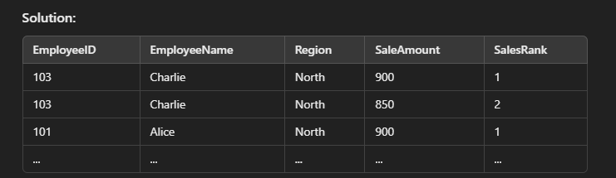
- Show the moving average of sales over 3 consecutive sales records for each employee.
SELECT EmployeeID, EmployeeName, SaleDate, SaleAmount,
AVG(SaleAmount) OVER (PARTITION BY EmployeeID ORDER BY SaleDate ROWS 2 PRECEDING) AS MovingAvg
FROM employee_sales;
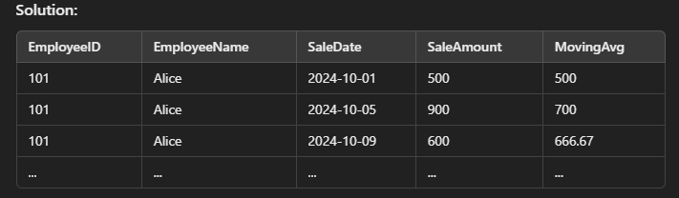
- Find the difference between each sale amount and the previous sale amount for each employee.
SELECT EmployeeID, EmployeeName, SaleDate, SaleAmount,
SaleAmount - LAG(SaleAmount) OVER (PARTITION BY EmployeeID ORDER BY SaleDate) AS SaleDifference
FROM employee_sales;
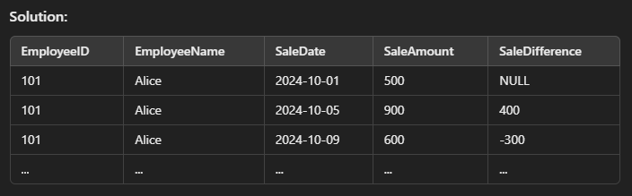
- Determine the top 3 sales in each region.
SELECT EmployeeID, EmployeeName, Region, SaleAmount,
DENSE_RANK() OVER (PARTITION BY Region ORDER BY SaleAmount DESC) AS SalesRank
FROM employee_sales
WHERE SalesRank <= 3;
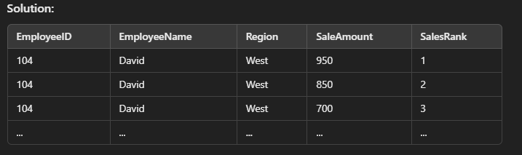
Explanation
The examples use various window functions to showcase how they work:
- Cumulative totals allow us to see running totals for each employee.
- Ranking helps identify top sales records within specific partitions.
- Moving averages smooth out the sales trend over time.
- LAG function reveals the difference between consecutive sales for trend analysis.
These exercises and solutions provide a solid foundation for understanding and applying window functions in MySQL.

CREATE TABLE employees (
emp_no INT PRIMARY KEY AUTO_INCREMENT,
department VARCHAR(20),
salary INT
);

INSERT INTO employees (department, salary) VALUES
('engineering', 80000),
('engineering', 69000),
('engineering', 70000),
('engineering', 103000),
('engineering', 67000),
('engineering', 89000),
('engineering', 91000),
('sales', 59000),
('sales', 70000),
('sales', 159000),
('sales', 72000),
('sales', 60000),
('sales', 61000),
('sales', 61000),
('customer service', 38000),
('customer service', 45000),
('customer service', 61000),
('customer service', 40000),
('customer service', 31000),
('customer service', 56000),
('customer service', 55000);

SELECT emp_no, department, salary, AVG(salary) OVER() FROM employees;

SELECT
emp_no,
department,
salary,
MIN(salary) OVER(),
MAX(salary) OVER()
FROM employees;

SELECT
emp_no, department, salary, MIN(salary), MAX(salary)
FROM
employees;
PARTITION BY
SELECT
emp_no,
department,
salary,
AVG(salary) OVER(PARTITION BY department) AS dept_avg,
AVG(salary) OVER() AS company_avg
FROM employees;

SELECT
emp_no,
department,
salary,
COUNT(*) OVER(PARTITION BY department) as dept_count
FROM employees;

SELECT
emp_no,
department,
salary,
SUM(salary) OVER(PARTITION BY department) AS dept_payroll,
SUM(salary) OVER() AS total_payroll
FROM employees;

ORDER BY with Windows
- SELECT
- emp_no,
- department,
- salary,
- SUM(salary) OVER(PARTITION BY department ORDER BY salary) AS rolling_dept_salary,
- SUM(salary) OVER(PARTITION BY department) AS total_dept_salary
- FROM employees;

- SELECT
- emp_no,
- department,
- salary,
- MIN(salary) OVER(PARTITION BY department ORDER BY salary DESC) as rolling_min
- FROM employees;

Rank
- SELECT
- emp_no,
- department,
- salary,
- ROW_NUMBER() OVER(PARTITION BY department ORDER BY SALARY DESC) as dept_row_number,
- RANK() OVER(PARTITION BY department ORDER BY SALARY DESC) as dept_salary_rank,
- RANK() OVER(ORDER BY salary DESC) as overall_rank,
- DENSE_RANK() OVER(ORDER BY salary DESC) as overall_dense_rank,
- ROW_NUMBER() OVER(ORDER BY salary DESC) as overall_num
- FROM employees ORDER BY overall_rank;

First Value CODE
- SELECT
- emp_no,
- department,
- salary,
- FIRST_VALUE(emp_no) OVER(PARTITION BY department ORDER BY salary DESC) as highest_paid_dept,
- FIRST_VALUE(emp_no) OVER(ORDER BY salary DESC) as highest_paid_overall
- FROM employees;

LEAD Value CODE

- SELECT
- emp_no,
- department,
- salary,
- salary - LAG(salary) OVER(ORDER BY salary DESC) as salary_diff
- FROM employees;

- SELECT
- emp_no,
- department,
- salary,
- salary - LAG(salary) OVER(PARTITION BY department ORDER BY salary DESC) as dept_salary_diff
- FROM employees;

